2.86: a) The helicopter accelerates from rest for 10.0 s at a constant 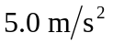. It thus reaches an upward velocity of
and a height of at the moment the engine is shut off. To find the helicopter's maximum height use
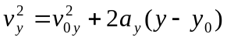
Taking 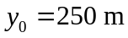, where the engine shut off, and since 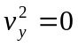 at the maximum height:
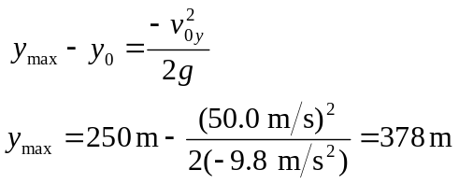
or 380 m to the given precision.

b) The time for the helicopter to crash from the height of 250 m where Powers stepped out and the engine shut off can be found from:
where we now take the ground as 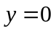. The quadratic formula gives solutions of 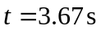and 13.88 s, of which the first is physically impossible in this situation. Powers' position 7.0 seconds after the engine shutoff is given by:

at which time his velocity is
Powers thus has 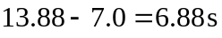 more time to fall before the helicopter crashes, at his constant downward acceleration of 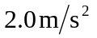. His position at crash time is thus:
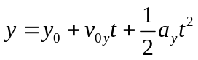
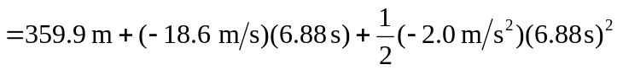
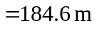

or 180 m to the given precision.

